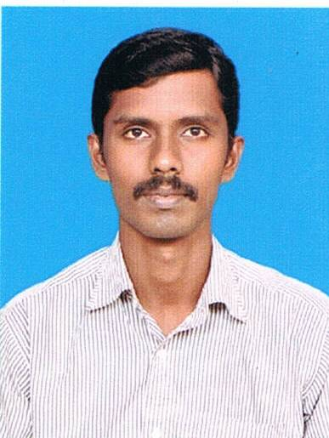
SELVAM N
74/3 Arattu road,
Near S,M.R.V School,
Vadaseri,
Nagercoil,
Tamilnadu-629001.
Email: selvamnatarajan10@gmail.com
Mobile: +919566150478

CAREER OBJECTIVE:
To pursue a career in a dynamic and stable workplace, where I can utilize my Knowledge to solve challenges in a creative and effective manner.

EDUCATION QUALIFICATION:

- 2009-2012 : B.E.Automobile Engineering, Rajalakshmi Engineering College,
Anna University, Chennai (CGPA 7.09)

- 2006-2009: Diploma in automobile engineering,K.N.S.K Polytechnic college,Nagercoil,
(Aggregate 84.5%)

- 2001-2002 : ITI(Welder)Government ITI Nagercoil,

- 2000-2001 : SSLC, D.V.D Higher Secondary school,Nagercoil.State Board(74.4%)

INDUSTRIAL VISITS:

- Delphi TVS
- Popular motors
- Super auto Forge

PROJECTS UNDERTAKEN:

- Design and fabrication of Electric Two Wheeler

EXPERIENCE:

- One year apprentice welder in RANE ENGINE VALVES Ltd.,Chennai

SOFTWARE SKILLS:

- MS-OFFICE
- AutoCAD,
- Pro-E

AREAS OF INTEREST:

- Chassis and transmission and Manufacturing Process.

STRENGTHS:

- Hard working, Team Player and good leadership skills

PERSONAL PROFILE:
: 31-07-1986
: 26 yrs.
: Bachelor
: Male
: English,Tamil
: C.Natarajan

Date of Birth
Age
Marital Status
Gender Languages Known Father’s Name

REFERENCE:

- Philip Praveen, Director of Training & Placement -REC/RIT

Authentically,

N.SELVAM

